The report of mini-project N3 program
by Ulvi Bajarani
SID 20539914

All retrieved results and processings are saved in the log file created by the program (if the log files don’t exist, the program creates it. Otherwise, it appends): logFile.txt

The program processes all images that must be in the /imagesToProcess/Images folder located in the same folder with the /python folder. In other words, /imagesToProcess/Images folder must be one level up than the code file. The templates are saved in /imagesToProcess/Templates folder located in the same folder with the /python folder. In other words, /imagesToProcess/Templates folder must be one level up than the code file. All templated named as image_name_template.extension format. While the image dimensions are 512x512, template dimensions are 32x32 and the templates made from the images resized to 256x256 (included in /imagesToProcess/resizedImages folder)

The .py file could be found in /python folder. The image processing results are saved in the /resultsOfProcessing folder. The /python folder contains the code files.

The function picture_writer(images_list, folder_path_to_process, folder_path_for_templates, folder_path_to_write, templates_list, no_of_levels, metric) takes the list of images images_list, the folder path to get image names folder_path_to_process, the folder path to get image template names folder_path_for_templates, the folder name to write folder_path_to_write, the list of image templates templates_list, number of pyramid levels no_of_levels, and the correlation metric metric. The metrics were used:

Normalized Sum of Squared Differences – the variable name is cv2.TM_SQDIFF_NORMED In the processed file names, the files are named with additional ‘1’
Normalized Cross Correlation – the variable name is cv2.TM_CCORR_NORMED
In the processed file names, the files are named with additional ‘3’

The template matching is done by cv2.matchTemplate(layer,template,metric) function, while the pyramids are created by cv2.pyrDown(layer) function. The locations are got by cv2.minMaxLoc(result) function. All results for one image are concatenated in one image. The images with lower resolutions are written to the black image with the same number of rows as the highest layer (512). The concatenation is done horizontally by cv2.hconcat([image1, image2]) function.
The result image contains, from left to right:
1) Original image, undetected
2) Layer 0 (Original image), detected (with black square)
3) Layer 1, detected (with black square)
4) Layer 2, detected (with black square)
5) The template used
The program describes the actual state of processing. In the screenshot below, it can be seen that what processes ended.

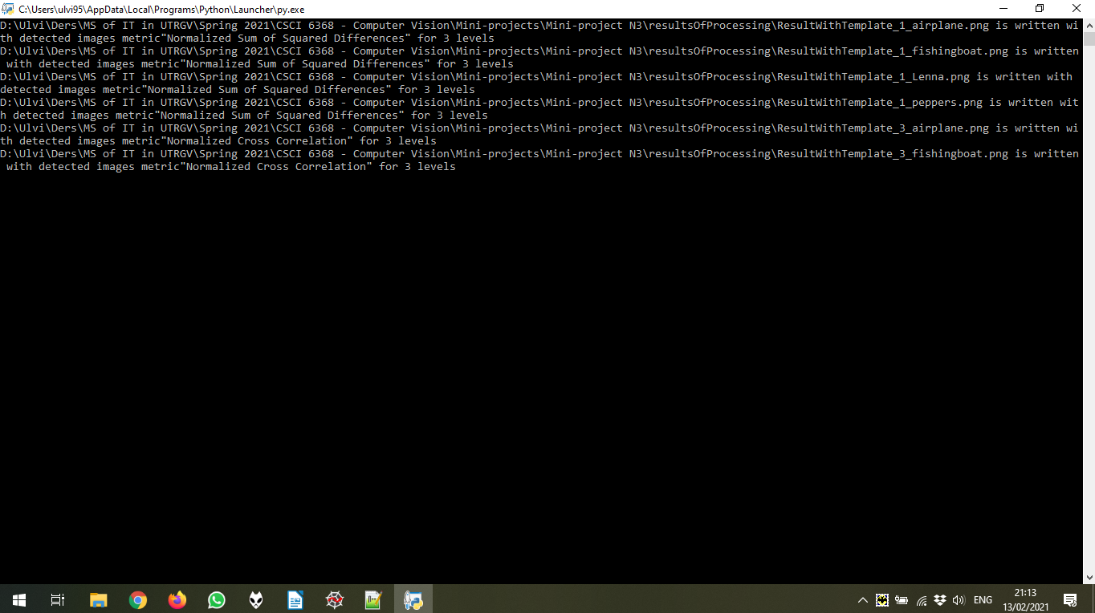

Below the result of processing for 1 image (out of 4) chosen randomly. As mentioned above, all results could be found in the /resultsOfProcessing folder.

With Normalized Sum of Squared Differences
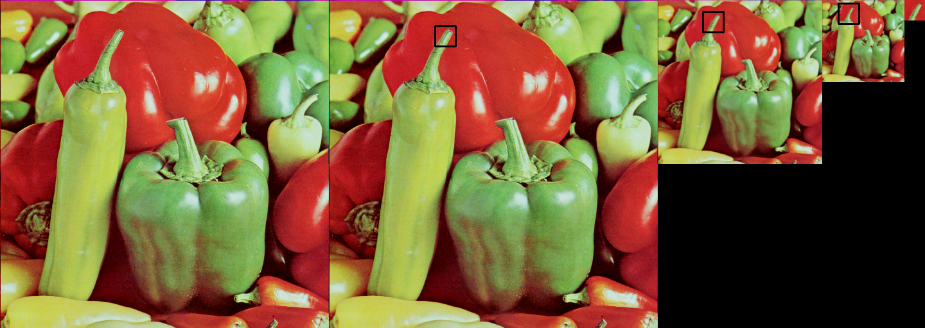
With Normalized Cross Correlation

